DDL Commands with Constraints – PRIMARY, FOREIGN KEY, UNIQUE, CHECK

AIM:
To add the constraints like primary key, foreign key, unique key and check using DDL commands.

Description:

PRIMARY KEY:
The PRIMARY KEY constraint uniquely identifies each record in a database table. Primary keys must contain UNIQUE values, and cannot contain NULL values.
A table can have only one primary key, which may consist of single or multiple fields.

FOREIGN KEY:
- A FOREIGN KEY is a key used to link two tables together.
- A FOREIGN KEY is a field (or collection of fields) in one table that refers to the PRIMARY KEY in another table.
- The table containing the foreign key is called the child table, and the table containing the candidate key is called the referenced or parent table.

UNIQUE Constraint:
- The UNIQUE constraint ensures that all values in a column are different.
- Both the UNIQUE and PRIMARY KEY constraints provide a guarantee for uniqueness for a column or set of columns.
- A PRIMARY KEY constraint automatically has a UNIQUE constraint.
- However, you can have many UNIQUE constraints per table, but only one PRIMARY KEY constraint per table.

CHECK Constraint:
- The CHECK constraint is used to limit the value range that can be placed in a column
- If you define a CHECK constraint on a single column it allows only certain values for this column.
- If you define a CHECK constraint on a table it can limit the values in certain columns based on values in other columns in the row.

PRIMARY:
ALTER TABLE table_name
ADD PRIMARY KEY(primary_key_column);

FOREIGN KEY:
ALTER TABLE table_name
ADD CONSTRAINT constraint_name FOREIGN KEY foreign_key_name (columns) REFERENCES parent_table(columns)
ON DELETE action ON UPDATE action

UNIQUE:
CREATE TABLE table_1(
...
column_name_1 data_type,
...
UNIQUE(column_name_1)
);

CHECK
CREATE TABLE IF NOT EXISTS parts ( part_no VARCHAR(18) PRIMARY KEY,
description VARCHAR(40),
cost DECIMAL(10 , 2 ) NOT NULL CHECK(cost > 0), price DECIMAL (10,2) NOT NULL
);

Questions:
- Alter the table EMPLOYEE with following structure.

# | Column Name | Constraints
1 | EmpID | PRIMARY KEY

- Alter the table name DEPARMENT with following structure.

# | Column Name | Constraints
1 | DeptID | PRIMARY KEY

Alter the table name EMPLOYEE with following structure.

# | Column Name | Constraints
1 | ACCOUNTNo | UNIQUE KEY

Alter the table name EMPLOYEE with following structure.

# | Column Name | Constraints
1 | Phone No | Check(phone no >=6000000 and <=9999999999)

Alter the table name EMPLOYEE with following structure.

# | Column Name | Constraints
1 | DeptID | FOREIGN KEY REFERENCES DEPARTMENT(DeptID)
- Insert records into the DEPARTMENT table first, then insert records into the EMPLOYEE table using valid DeptID values to verify that the foreign key works correctly.

OUTPUTS:
1)
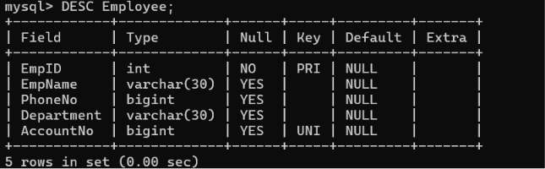

2)

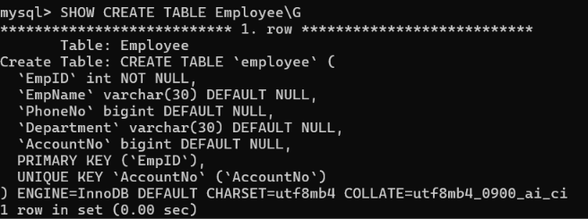
3)
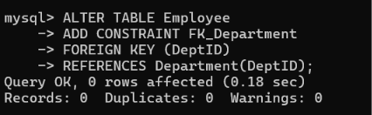

4)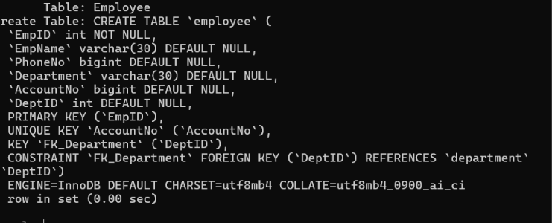

Result:
DDL Commands with Primary, Foreign, Unique, Check constraints are updated and verified.

